
LA GRANDEE INTERNATIONAL COLLEGE
Simalchaur, Pokhara, Nepal

A Project Proposal
on
PhishGuard

Submitted to
Bachelor of Computer Application (BCA) Program
LA GRANDEE International College

In partial fulfillment of the requirements for the degree of Bachelor of Computer
Application under Pokhara University

Submitted by
Name of the Student | PU Registration Number | Semester
Deven Shrestha | 2023-1-53-0325 | VI
Shital Dhakal | 2023-1-53-0345 | VI

June, 2026

Table of Contents
Table of Contents ii
List of Figures iv
List of Tables v
1. Introduction 1
1.1 Background 1
1.2 Objectives 2
1.3 Purpose, Scope, and Applicability 2
1.3.1 Purpose 2
1.3.2 Scope 2
1.3.3 Applicability 5
1.4 Achievements (Mid-Term Progress) 5
1.5 Organization of Report 6
2. SURVEY OF TECHNOLOGIES 8
3. REQUIREMENTS AND ANALYSIS 10
3.1 Problem Definition 10
3.2 Requirements Specification 10
3.2.1 Functional Requirements 10
3.2.2 Non-Functional Requirements 13
3.3 Planning and Scheduling 14
3.4 Software and Hardware Requirements 15
3.5 Preliminary Product Description 15
3.5.1 Current System Features 15
3.5.2 Future Features 16
3.6 Conceptual Models 17
4. DESIGN 18
4.1 Introduction 18
4.2 System Design 18
4.2.1 Design Methodology 19
4.2.2 Data Flow Diagram (DFD) 20
4.2.3 UML Class Diagram 22
4.2.4 Use Case Diagram 24
4.3 Database Design 24
4.4 Interface Design 26
4.5 Summary 27
5. IMPLEMENTATION AND TESTING 28
5.1 Implementation Approaches 28
5.2 Coding Details and Code Efficiency 28
5.3 Testing Approach 29
5.3.1 Unit Testing 29
5.3.2 Integrated Testing 29
5.3.3 Beta Testing 30
5.4 Modifications and Improvements 30
5.5 Test Cases 31
6. RESULTS AND DISCUSSION 32
6.1 Test Reports 32
6.2 User Documentation 33
7. CONCLUSIONS 35
7.1 Conclusion 35
7.1.1 Significance of the System 35
7.2 Limitations of the System 36
7.3 Future Scope of the Project 36
References 38

List of Figures
Figure 3.3.0-1 - Gantt Chart 14
Figure 4.2.2.0-1 - DFD Level 0 21
Figure 4.2.2.0-2 - DFD Level 1 21
Figure 4.3.1 - ER Diagram 25

List of Tables

Table 5.5.1 - Test Cases 31

Introduction

1.1 Background
Email has become the primary communication channel for modern organizations, with an estimated 347 billion emails sent and received worldwide each day (Statista, 2024). However, this widespread adoption has made email the most exploited attack vector in cybersecurity. According to the Anti-Phishing Working (APWG, 2024), over 4.7 million phishing attacks were recorded in 2023 alone, marking a significant rise in email-based threats targeting organizations across all sectors. Phishing attacks are a form of social engineering where malicious actors impersonate trusted entities such as banks, service providers, or internal departments to deceive recipients into revealing sensitive information, clicking on malicious links, or downloading harmful attachments (Chiew et al., 2018). These attacks often bypass basic spam filters by using sophisticated techniques such as lookalike domains, URL obfuscation, urgency-driven language, and legitimate email authentication through compromised or free email accounts (Nightingale, 2017). To address these challenges, PhishGuard is a web-based application built using the Django framework (Python) that provides a centralized platform for submitting, analyzing, classifying, and visualizing email threats. The system automates the email investigation process by parsing email headers, extracting indicators of compromise (IOCs), analyzing URLs and keywords for phishing patterns, classifying emails into threat categories, and calculating risk scores — reducing the analysis time from 15–30 minutes to under 30 seconds per email. The platform also incorporates data analysis using Pandas and data visualization using Matplotlib and Chart.js to provide actionable insights into email threat trends across the organization.

1.2 Objectives
- Develop a web-based email analysis platform that automatically retrieves and processes emails forwarded from employee mailboxes to a centralized reporting mailbox for analysis.
- Implement an automated email analysis engine that parses headers, extracts indicators of compromise (IOCs) such as URLs, IP addresses, and domains, and detects phishing-related keywords and urgency patterns in the email body.

1.3 Purpose, Scope, and Applicability

1.3.1 Purpose
The project will focus on the following specific objectives:
- Develop a web-based email analysis platform that automatically retrieves and processes emails forwarded from employee mailboxes to a centralized reporting mailbox for analysis.
- Implement an automated email analysis engine that parses headers, extracts indicators of compromise (IOCs) such as URLs, IP addresses, and domains, and detects phishing-related keywords and urgency patterns in the email body.

1.3.2 Scope
- Email Ingestion via Auto-Forwarding and IMAP:
    - The system uses a post-delivery scanning architecture. Employee mailboxes are configured with auto-forwarding rules to send copies of all incoming emails to a central reporting mailbox (e.g., reports@organization.com).
    - The platform connects to the reporting mailbox via IMAP, retrieves all forwarded emails, and processes each through the analysis engine. This ensures every organisational email is scanned without manual employee action.
    - Users, including employees and analysts, can also manually submit suspicious emails for analysis by pasting the raw email content into a web form for ad-hoc investigation.
  - Automated Email Analysis:
- Parse email headers to extract sender information (From, Reply-To, Return-Path), recipient details, subject line, and authentication results (SPF, DKIM, DMARC).
- Extract indicators of compromise (IOCs) from the email body, including IP addresses, URLs, domain names, and email addresses.
- Analyse extracted URLs for suspicious features such as URL shortening, IP-based URLs, misspelled domains, suspicious TLDs, and excessive subdomain depth.
- Detect phishing-indicative keywords and urgency patterns in the email body and subject line using a weighted keyword scoring system.
- Classification and Risk Scoring:
- Classify each analysed email into one of three categories: Clean, Spam, or Phishing.
- For phishing emails, further classify the phishing type into sub-categories: credential harvesting, fake invoice, account suspension, banking fraud, delivery scam, reward scam, malware attachment, or unknown.
- Calculate a risk score from 0 to 100 based on weighted analysis results across multiple detection categories (authentication failures, header anomalies, URL features, keyword indicators, and threat intelligence lookups).
- Assign a verdict: Safe (0–30), Suspicious (31–60), or Malicious (61–100).
- Report Management:
- Store all analysis results as structured reports in the database with full CRUD (Create, Read, Update, Delete) operations.
- Allow analysts to review reports, update verdicts, add investigation notes, and mark false positives.
- Provide search and filtering capabilities across all analysis reports.
- Data Analysis and Visualisation:
- Perform data analysis using Pandas to compute email threat statistics, including phishing category distribution, risk score trends over time, spam-to-ham ratios, and detection accuracy metrics.
- Generate server-side charts using Matplotlib for trend analysis (phishing volume over time, category-wise average risk scores, vulnerability aging).
- Display interactive, browser-based charts using Chart.js on the dashboard (severity distribution pie chart, recent analysis bar chart, risk trendline chart).
- Data Export:
- Export analysis reports, IOC lists, and trend data in CSV format and as PDF for external use and management reporting.

1.3.3 Applicability
The system is applicable to:
- Individuals and email users who want to detect and analyze suspicious or phishing emails.
- Organizations and businesses seeking to improve email security and protect employees from phishing attacks.
- Cybersecurity analysts and researchers for investigating email threats and analyzing Indicators of Compromise (IOCs).
- Educational institutions and students for learning and demonstrating phishing detection techniques and email security concepts

1.4 Achievements (Mid-Term Progress)
The major accomplishments completed up to the mid-term evaluation are listed below:
- Created database structure for email and analysis modules
  - EmailRecord and EmailAttachment tables implemented with relational constraints
  - IOC (Indicator of Compromise) table setup completed to track suspicious inputs
  - Database integration and migrations successfully completed with PostgreSQL
- Developed and connected email fetcher service (backend)
  - Secure SSL-encrypted IMAP connection established with monitored mailbox
  - Automated email fetching logic implemented for both INBOX and Spam folders
  - Authentication successfully handled using secure App Passwords
- Designed and implemented email parsing service
  - Header parsing completed for Sender, Recipient, CC, BCC, Subject, and Date
  - Content separation implemented for multipart Plain Text and HTML bodies
  - Basic spoofing detection implemented for display-name vs domain mismatch
- Developed Indicator of Compromise (IOC) extraction engine
  - URL extraction and domain name resolution completed
  - Regular expression–based IP address extraction with 0–255 octet range validation implemented
  - SHA-256 hash generation completed for attachment forensic tracking
  - In-memory deduplication logic implemented to prevent database duplicates
- Integrated external threat intelligence APIs
  - AbuseIPDB API integrated for real-time IP address reputation lookups
  - VirusTotal API integrated for URL, domain, and file hash threat lookups
  - Custom rate-limiting and retry mechanisms implemented to respect free-tier API limits (4 requests per minute)
- User Management
  - Admin can add or ban users
  - Analyst can setup imap credentials
  - Any user can change their own credentials

1.5 Organization of Report
This mid-term report is organized into the following sections:
- Introduction: Provides background context on email phishing threats, project objectives, and achievements.
- Survey of Technologies: Reviews similar email analysis platforms, threat intelligence APIs, and the system's technology stack.
- Requirements and Analysis: Defines the functional and non-functional requirements for the ingestion, extraction, and analysis pipeline.
- Design: Explains the platform's modular system architecture, data flow diagrams (DFDs), and database ERD design.
- Implementation and Testing: Describes the backend implementation of the parser, extractor, and threat intel services, and details the test scenarios.
- Results and Discussion: Demonstrates the current database and pipeline outputs, including successful threat reputation scores.
- Conclusion: Summarizes the mid-term project milestones and outlines the future scope of development for the frontend and classifier models.

2. SURVEY OF TECHNOLOGIES
In most organizations, email security threats such as credential harvesting, fake invoices, banking fraud, and malicious attachments are handled through traditional methods like manual IT support tickets, email forwarding, and basic spam filters. These approaches often lack real-time risk scoring, automated threat intelligence verification, and centralized threat tracking dashboards.
Various email security tools are available to protect users from phishing and spam attacks. The following are some commonly used technologies and their key features and limitations.
- Gmail Spam Filter (Google): Built in email filter in gmail included for free in Gmail.
- Key Features:
  - Employs deep learning models trained on billions of emails daily to detect spam and phishing patterns (Kumaran et al., 2017)
  - Checks email authentication protocols (SPF, DKIM, DMARC) and flags authentication failures
  - Integrates with Google Safe Browsing to cross-reference URLs with known malicious sites (Google Cloud, 2023)
  - Scans all attachments for malware and blocks potentially harmful file types
  - Learns from user feedback when emails are reported as phishing or spam to improve detection accuracy
- Limitations:
  - Performs only binary classification, marking emails as Spam or Not Spam, without risk scoring or phishing category classification.
  - Lacks a dashboard or analytics, so users cannot view phishing trends, category distribution, or organizational threat posture.
- KnowBe4 PhishER: Developed by KnowBe4, PhishER is a paid Security Orchestration, Automation, and Response (SOAR) platform designed to streamline an organization's phishing incident response process.
  - Key Features:
    - Employees report suspicious emails using a "Phish Alert Button" or by forwarding to a dedicated mailbox, similar to the proposed system's auto-forwarding architecture (KnowBe4, 2024).
    - Automatically prioritizes emails into three categories: Clean, Spam, or Threat, similar to the proposed system's classification.
- Limitations:
  - Enterprise-only with no free tier, making it inaccessible for small organizations or academic projects
  - Closed-source, so it cannot be customized, extended, or inspected for educational purposes
  - Relies on employees manually reporting emails using the Phish Alert Button rather than auto-scanning all emails

3. REQUIREMENTS AND ANALYSIS

3.1 Problem Definition
Email phishing remains the primary entry point for cyberattacks, exploiting human behavior rather than software vulnerabilities. Organizations face three key challenges in managing these threats:
- Slow Manual Investigations: Security analysts must manually inspect raw headers, check SPF/DMARC authentication, and lookup URLs in threat databases. This manual forensic process is slow, prone to error, and delays incident response.
- Limitations of Standard Filters: Native spam filters typically perform only binary (Spam/Not Spam) categorization. They do not calculate granular risk scores, identify the specific sub-category of the threat, or explain their verdicts.
- Lacking Centralized Visibility: Organizations lack a central console to track reported emails. Without interactive threat dashboards, administrators cannot monitor attack patterns, track security metrics, or make data-driven security decisions.
PhishGuard addresses these problems by providing an automated, web-based platform that ingests reported emails, runs them through a multi-layered analysis pipeline (header check, keyword scan, and external API lookup), calculates risk scores, and displays visual security trend statistics to analysts.

3.2 Requirements Specification
The requirements of PhishGuard are divided into Functional Requirements and Non-Functional Requirements.

3.2.1 Functional Requirements

A. User & Account Management Module
- FR-UM-001: Account Management and RBAC
  - The system shall allow users to register, login, and manage their accounts.
  - The system shall provide secure login and logout functionality.
  - The system shall enforce Role-Based Access Control with three distinct roles: Employee, Security Analyst, and Administrator.
  - Current Status: Planned for the next development phase.

B. Email Ingestion Module
- FR-IM-001: Automated IMAP Fetching
  - The system shall connect to a configured centralized reporting mailbox via IMAP protocols.
  - The system shall automatically fetch unseen emails forwarded from employee mailboxes.
  - The system shall parse and persistently save emails to the database as EmailRecord objects.
  - Current Status: Implemented and tested.
- FR-IM-002: Manual Email Submission
  - The system shall allow users to manually submit suspicious emails via a web form.
  - The system shall support pasting raw email content (full headers and body text).
  - Current Status: Planned for the next development phase.

C. Core Email Analysis Engine
- FR-AE-001: Header Parsing and Extraction
  - The system shall parse email headers to extract sender fields (From, Reply-To, Return-Path).
  - The system shall parse authentication results including SPF, DKIM, and DMARC alignments.
  - The system shall extract the received headers chain to trace the email routing history.
  - Current Status: Implemented and tested.
- FR-AE-002: IOC and File Hash Extraction
  - The system shall extract Indicators of Compromise (IOCs) including URLs, domains, and IP addresses.
  - The system shall generate SHA-256 hashes of all file attachments.
  - The system shall deduplicate extracted IOCs to prevent redundant database entries.
  - Current Status: Implemented and tested.
- FR-AE-003: Keyword and Urgency Detection
  - The system shall scan the email subject and body for phishing keywords.
  - The system shall categorize keywords into weighted urgency, financial, call-to-action, and security groups.
  - Current Status: Reference design completed. Backend implementation is currently under development.
- FR-AE-004: Threat Intelligence Reputation Lookup
  - The system shall query AbuseIPDB API for sending server IP address reputations.
  - The system shall query VirusTotal API for URL, Domain, and File Hash reputations.
  - The system shall enforce rate-limiting pauses to respect free-tier API quotas.
  - Current Status: Implemented and tested.
- FR-AE-005: ML Spam Classification
  - The system shall classify email body text as spam or ham using a trained Naive Bayes machine learning model.
  - Current Status: Planned for next development phase.
- FR-AE-006: Risk Scoring and Verdict
  - The system shall calculate a combined risk score from 0 to 100 based on weighted analyzer metrics.
  - The system shall assign a final threat verdict of Safe, Suspicious, or Malicious.
  - The system shall sub-classify phishing categories (e.g. credential harvesting, fake invoice).
  - Current Status: Planned for next development phase.

D. Report & Dashboard Module
- FR-RD-001: Report Storage and CRUD Operations
  - The system shall store all email scan results as reports in the database.
  - The system shall allow security analysts to perform full CRUD operations (view, update verdicts, delete, add notes) on analysis reports.
  - Current Status: Planned for next development phase.
- FR-RD-002: Interactive Dashboard and Visualizations
  - The system shall display statistical threat summaries on an interactive dashboard.
  - The system shall represent category distribution and threat severity using Chart.js charts.
  - Current Status: Planned for the final development phase.

3.2.2 Non-Functional Requirements
- NFR-01: Performance
  - The system shall parse email bytes and extract metadata in under 2 seconds.
  - The system shall handle external API latency using asynchronous checks or rate-limit queues.
  - Current Status: Parser and extractor optimization completed.
- NFR-02: Security
  - The system shall encrypt user passwords and store them securely.
  - The system shall protect backend analysis scripts from malicious code injection.
  - The system shall securely store third-party API credentials in environment variables (.env).
  - Current Status: API key and database configurations secured.
- NFR-03: Scalability
  - The system shall support concurrent analysis requests without system degradation.
  - The system shall follow a modular service architecture to allow easy integration of additional scanning tools.
  - Current Status: Considered during modular backend architecture design.
- NFR-04: Reliability
  - The system shall prevent data loss of fetched emails and reports during database operations.
  - The system shall maintain referential data consistency between emails, attachments, and IOC tables.
  - Current Status: Relational database integrity successfully validated on PostgreSQL.
- NFR-05: Maintainability
  - The system shall organize code in independent services to allow easy debugging.
  - Current Status: Modular folder organization (analyzer/services/) successfully implemented.
- NFR-06: Portability & Usability
  - The web interface shall be fully responsive across desktop, tablet, and mobile browsers.
  - The system shall optionally support containerized deployment via Docker.
  - Current Status: Planned for final deployment phase.
- NFR-07: Data Portability
  - The system shall allow security analysts to export analysis reports in CSV and PDF formats.
  - Current Status: Planned for final development phase.

3.3 Planning and Scheduling
The development of PhishGuard follows the Agile Software Development Methodology. The project activities are planned and scheduled across different iterative phases to ensure the timely and structured implementation of the email security platform.
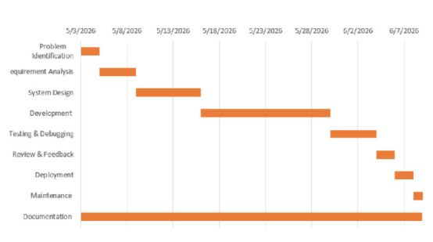
Figure 3.3.0-1 - Gantt Chart

3.4 Software and Hardware Requirements
The development and deployment of the Email Phishing Detection and Analysis Platform (PhishGuard) require specific hardware and software components. These requirements are divided into the following categories:
Software Requirements
- Python 3.x (Programming Language)
- Django (Backend Web Framework)
- PostgreSQL (Relational Database Management System)
- HTML5, CSS3, and Bootstrap (Frontend Development and Styling)
- JavaScript (Client-side Interactivity)
- Visual Studio Code (VS Code) (Integrated Development Environment)
- Git and GitHub (Version Control and Source Code Management)
- Postman (API Testing and Development)
- IMAP-enabled Email Service (e.g., Gmail) (Email Fetching)
- VirusTotal API and AbuseIPDB API (Threat Intelligence Integration)

Hardware Requirements
- Minimum 4 GB RAM (8 GB recommended)
- Dual-core processor or higher
- Stable internet connection (for email retrieval, threat intelligence API calls, and development)
- A computer capable of running Python, PostgreSQL, and Django applications

3.5 Preliminary Product Description
PhishGuard is a web-based Email Phishing Detection and Analysis Platform designed to automate the detection and investigation of suspicious emails. The system retrieves emails from configured mailboxes, extracts Indicators of Compromise (IOCs) such as URLs, domains, IP addresses, email addresses, and file hashes, and analyzes them using email header inspection and external threat intelligence services.

3.5.1 Current System Features
A. Email Ingestion Module
- Automated IMAP Email Retrieval from Inbox and Spam folders
- MIME Email Parsing (Headers, Plain Text, HTML Body, and Attachments)
- Email Deduplication and Storage in PostgreSQL Database
B. IOC Extraction and Threat Intelligence Module
- Extraction of URLs, Domains, IP Addresses, Email Addresses, and File Hashes
- SHA-256 File Hash Generation for Email Attachments
- Reputation Lookup using AbuseIPDB (IPs) and VirusTotal (URLs, Domains, and File Hashes)
C. Email Analysis Module
- Email Header Analysis (SPF, DKIM, DMARC, Return-Path, and Reply-To)
- Display Name Mismatch Detection
- IOC Deduplication and Structured Database Storage
D. Database and Security
- PostgreSQL Relational Database Integration
- Secure API Key Management using Environment Variables (.env)
- Modular Django-Based Backend Architecture

3.5.2 Future Features
A. User Management Module
- User Registration and Login
- Role-Based Access Control (RBAC)
- Secure Authentication and Session Management
B. Advanced Phishing Detection Module
- Machine Learning–Based Email Classification
- Keyword and Social Engineering Detection
- Enhanced Risk Scoring and Threat Verdict Generation (Safe, Suspicious, Malicious)
C. Dashboard and Reporting Module
- Interactive Dashboard for Email Analysis Results
- Historical Threat Analytics and Visualizations
- Exportable Analysis Reports (CSV/PDF)
The current implementation establishes the core infrastructure for phishing email collection, IOC extraction, and threat intelligence integration, providing a scalable foundation for future enhancements such as machine learning, user management, and advanced reporting capabilities.

3.6 Conceptual Models
The Conceptual Model describes the high-level structure and workflow of the PhishGuard system, illustrating how different components interact to detect and analyze phishing emails.
Key Components
- Email Source: Emails are retrieved from configured mailboxes using the IMAP protocol.
- Email Parsing Module: Parses email headers, body content, and attachments to extract relevant information.
- IOC Extraction Module: Identifies Indicators of Compromise (IOCs) such as URLs, domains, IP addresses, email addresses, and file hashes.
- Threat Intelligence Module: Verifies extracted IOCs using external services such as VirusTotal and AbuseIPDB.
- Risk Analysis Module: Combines header analysis, IOC reputation, and other detection techniques to calculate a phishing risk score.
- Database: Stores emails, attachments, extracted IOCs, and analysis results in PostgreSQL.
- User Interface: Presents analysis results, threat information, and reports through a web-based dashboard.
Current Mid-Term Status: The core email retrieval, parsing, IOC extraction, and threat intelligence functionalities have been successfully implemented, while the advanced phishing detection, risk scoring, and reporting modules are currently under development.

4. DESIGN

4.1 Introduction
The design phase is one of the most important stages in the Software Development Life Cycle (SDLC). It provides a detailed blueprint for the development of the PhishGuard system by defining the system architecture, database structure, data flow, and user interfaces. The purpose of this phase is to transform the requirements identified during the analysis phase into a structured design that can be implemented efficiently.
The PhishGuard system has been designed with a modular architecture that separates the email ingestion, analysis engine, threat intelligence, and database components. This approach improves maintainability, scalability, and overall system performance. The design also ensures that future enhancements, such as advanced machine learning models, real-time monitoring, user authentication, and interactive dashboards, can be integrated without major modifications to the existing system.
To represent different aspects of the system design, various modeling techniques have been used, including Data Flow Diagrams (DFD), UML Class Diagrams, and Entity Relationship (ER) Diagrams. These models provide a clear understanding of the system's structure, data processing workflow, and interactions between different components.

4.2 System Design
The PhishGuard system follows a modular architecture that separates different functionalities into independent components. This design improves scalability, maintainability, and simplifies future enhancements. The major components of the system are as follows:
- Email Ingestion Module
  - Connects securely to the configured mailbox using the IMAP protocol.
  - Retrieves emails from folders such as Inbox and Spam.
  - Stores fetched emails for further processing.
- Email Parsing Module
  - Extracts email headers, sender and recipient details, subject, body content, and attachments.
  - Separates plain-text and HTML content for analysis.
  - Parses authentication-related headers such as SPF, DKIM, and DMARC.
- IOC (Indicator of Compromise) Extraction Module
  - Extracts URLs, domains, IP addresses, email addresses, and file hashes.
  - Validates and removes duplicate IOCs before storing them.
  - Associates extracted IOCs with the corresponding email record.
- Threat Intelligence Module
  - Checks IP reputation using AbuseIPDB.
  - Checks URLs, domains, and file hashes using VirusTotal.
  - Stores reputation results and threat scores in the database.
- Risk Analysis Module
  - Combines results from email parsing and threat intelligence.
  - Evaluates suspicious indicators to determine the phishing risk level.
  - Generates an overall risk score for each analyzed email.
- Database Module
  - Stores email records, attachments, extracted IOCs, and analysis results in PostgreSQL.
  - Maintains relationships between emails and their associated indicators.
- Presentation Layer
  - Displays processed email information and analysis results through a web-based interface.
  - Provides users with access to extracted IOCs, threat intelligence findings, and phishing risk assessments.

4.2.1 Design Methodology
The development of PhishGuard follows the Agile Software Development Methodology, which emphasizes iterative development, continuous improvement, and flexibility in responding to changing requirements. Instead of developing the entire system at once, the project is divided into smaller modules that are implemented, tested, and refined incrementally.
The Agile approach has been applied in the following ways:
- Incremental Development: Features such as email fetching, email parsing, IOC extraction, and threat intelligence integration were developed in separate iterations.
- Continuous Testing and Improvement: Each module was tested individually and integrated with the overall system before proceeding to the next phase.
- Modular Implementation: The system is organized into independent components, making it easier to modify or enhance specific functionalities without affecting the entire application.
- Adaptability: New requirements, such as file hash analysis and HTML email support, were incorporated during development with minimal changes to the existing architecture.
- Frequent Feedback and Refinement: The project was regularly reviewed and improved based on testing results and evolving functional requirements.
By adopting the Agile methodology, the PhishGuard project achieves greater flexibility, maintainability, and scalability while ensuring that new features and improvements can be incorporated efficiently throughout the development process.

4.2.2 Data Flow Diagram (DFD)
A Data Flow Diagram (DFD) illustrates how data moves through the PhishGuard system, showing the interaction between users, system processes, the database, and external threat intelligence services. It provides a high-level view of how emails are collected, analyzed, and processed to detect potential phishing threats.

DFD Level 0
The Level 0 Data Flow Diagram provides a high-level overview of the PhishGuard system. It illustrates the interaction between external entities such as employees, analysts, and the email server with the Email Phishing Detection and Analysis Platform. The diagram shows how users submit email data, configure mailboxes, and receive analysis reports and dashboard information.
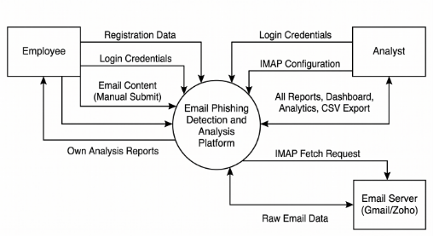
Figure 4.2.2.0-1 - DFD Level 0

DFD Level 1
The Level 1 Data Flow Diagram presents the internal processes of the PhishGuard system in greater detail. It includes user authentication, email ingestion, email analysis, report management, and dashboard generation. The diagram also shows the interaction with data stores such as user records, email records, IOC databases, analysis reports, and mailbox configurations.
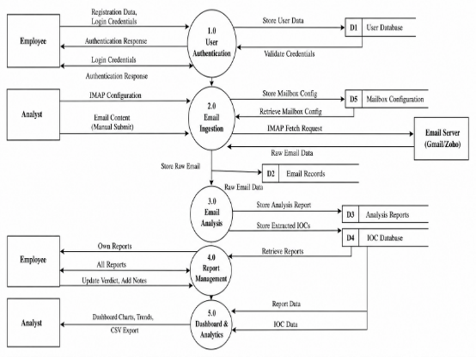
Figure 4.2.2.0-2 - DFD Level 1

4.2.3 UML Class Diagram
The UML Class Diagram illustrates the static structure of the PhishGuard system by showing its main classes, attributes, methods, and relationships. It includes key entities such as User, MailBoxConfig, EmailRecord, IOC, and AnalysisReport, demonstrating how they interact to support email retrieval, phishing analysis, IOC extraction, and report generation. This design promotes a modular and maintainable system architecture.

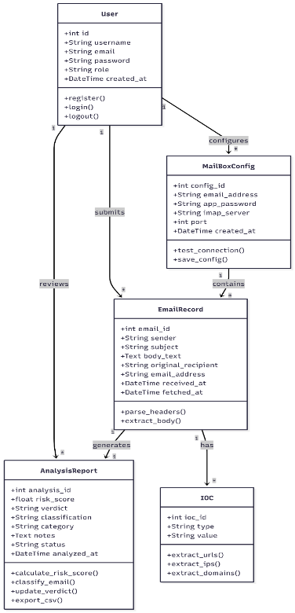
Figure 4.2.3.1 - UML Class Diagram

4.2.4 Use Case Diagram
The Use Case Diagram illustrates the interactions between the Employee and Analyst roles and the PhishGuard system. Employees can register, log in, submit emails for analysis, and view their analysis reports. Analysts can configure IMAP mailboxes, scan mailboxes, review reports, update verdicts and notes, view dashboards and analytics, and export reports. The diagram provides a high-level overview of the system's functionality and user interactions.
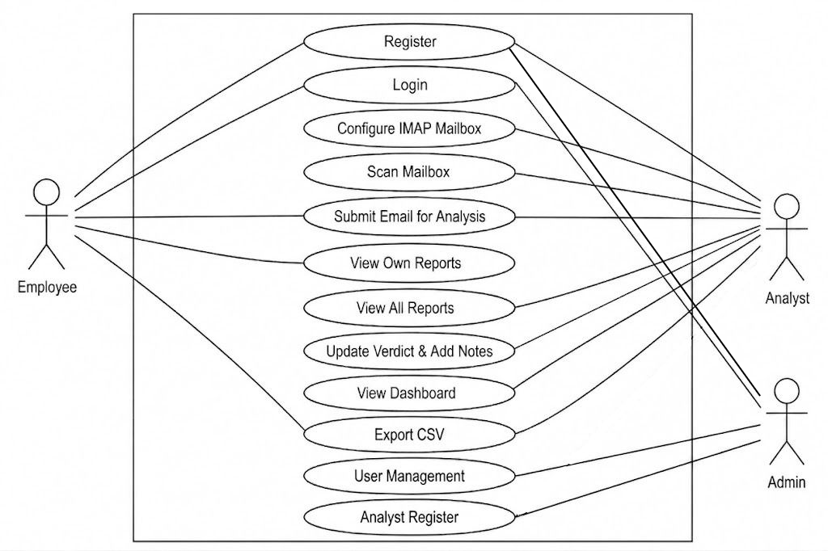
Figure 4.2.4.1 - Use Case Diagram

4.3 Database Design
The database design of PhishGuard is based on a relational model implemented using PostgreSQL. It is designed to efficiently store user information, mailbox configurations, email records, extracted Indicators of Compromise (IOCs), and analysis reports while maintaining proper relationships between entities.
The Entity Relationship (ER) diagram consists of the following main entities:
- User: Stores user account information, including username, email, password, role, and account creation details.
- MailBoxConfig: Maintains IMAP mailbox configuration required for automated email retrieval.
- EmailRecord: Stores fetched or manually submitted emails along with their metadata and content.
- IOC (Indicator of Compromise): Contains extracted URLs, domains, IP addresses, and email addresses associated with each email.
- AnalysisReport: Stores phishing analysis results, including risk score, verdict, classification, category, and analyst notes.
The relationships between these entities ensure data consistency and support efficient storage, retrieval, and analysis of phishing-related information. The database structure is scalable and can accommodate future enhancements with minimal modifications.
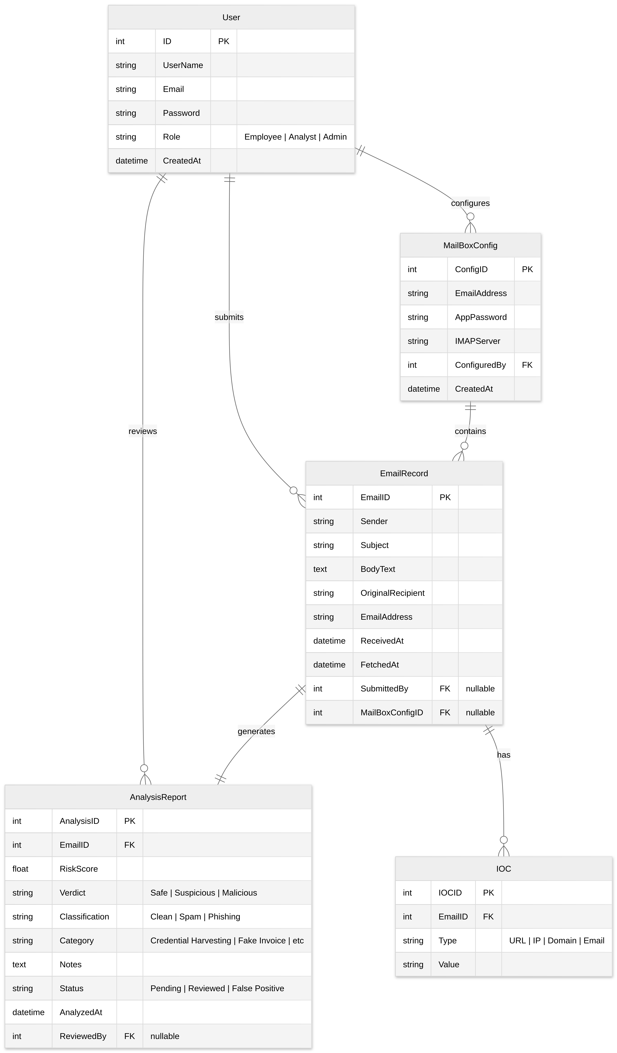
Figure 4.3.1 - ER Diagram

4.4 Interface Design
The interface design of PhishGuard focuses on providing a simple, intuitive, and user-friendly experience for interacting with the phishing detection system. The web-based interface is designed to enable users to configure mailboxes, initiate email analysis, and view analysis results efficiently.
The main interfaces of the system include:
Login Interface: Allows authorized users to securely access the system.

Mailbox Configuration Interface: Enables users to configure IMAP settings and manage email retrieval.

Email Analysis Interface: Displays fetched emails and their extracted details, including headers, body content, attachments, and Indicators of Compromise (IOCs).

Report Interface: Presents phishing analysis results, risk scores, and verdicts for each analyzed email.

Dashboard Interface: Provides an overview of analyzed emails, detected threats, and summary statistics to assist users in monitoring phishing activities.

The interface is designed with usability and scalability in mind, ensuring that additional features and visualizations can be integrated in future versions without significant changes to the overall layout.

4.5 Summary
This chapter presented the overall design of the PhishGuard system, including its architecture, design methodology, data flow, UML and ER diagrams, database structure, and user interface. The proposed design follows a modular and scalable approach, enabling efficient email retrieval, phishing analysis, IOC extraction, and threat intelligence integration. These design components provide a strong foundation for the implementation and testing phases discussed in the following chapter.

5. IMPLEMENTATION AND TESTING

5.1 Implementation Approaches
The PhishGuard system was implemented using a modular approach to ensure scalability and maintainability. The key implementation approaches include:
- Django and Python for backend development.
- PostgreSQL for storing emails, IOCs, and analysis results.
- IMAP integration for automated email retrieval.
- VirusTotal and AbuseIPDB APIs for threat intelligence and reputation checking.
- Modular services for email parsing, IOC extraction, and phishing analysis.
- Environment variables (.env) for secure management of API keys and sensitive credentials.

5.2 Coding Details and Code Efficiency
The PhishGuard system follows a modular coding structure, where each component is implemented independently to improve maintainability and scalability. The code is organized into reusable services for email fetching, parsing, IOC extraction, and threat intelligence integration.
Coding Details:
- Developed using Python and the Django web framework.
- Organized into separate modules for email retrieval, parsing, IOC extraction, and reputation checking.
- Uses PostgreSQL for structured data storage and management.
- Integrates external APIs such as VirusTotal and AbuseIPDB for threat analysis.
Code Efficiency:
- Uses IOC deduplication to prevent duplicate records in the database.
- Avoids repeated API calls by storing previously retrieved reputation results.
- Employs optimized database queries through Django ORM for efficient data access.
- Implements exception handling and modular functions to improve reliability and maintainability.

5.3 Testing Approach
The PhishGuard system was tested to ensure that its functionalities operate correctly and reliably. Testing was performed on individual modules as well as the integrated system to verify accurate email processing, IOC extraction, threat intelligence lookup, and data storage.

5.3.1 Unit Testing
Unit testing was performed to verify that individual components of the PhishGuard system function correctly in isolation. Each module was tested independently to ensure it produced the expected output for a given input.
The unit testing activities included:
- Testing the email fetching module to ensure successful retrieval of emails from configured mailboxes.
- Testing the email parsing module to verify accurate extraction of headers, body content, and attachments.
- Testing the IOC extraction module for correct identification of URLs, domains, IP addresses, email addresses, and file hashes.
- Testing the threat intelligence module to validate API integration with VirusTotal and AbuseIPDB.
- Testing the database operations to ensure proper storage and retrieval of emails, attachments, and IOCs.
The successful execution of these tests confirmed that each individual module performs its intended functionality correctly before integration with the complete system.

5.3.2 Integrated Testing
Integrated testing was conducted to verify that the different modules of the PhishGuard system work together correctly as a complete application. The interaction between email retrieval, parsing, IOC extraction, threat intelligence integration, and database storage was tested to ensure seamless data flow and accurate analysis.
The integration testing activities included:
- Verifying the complete workflow from email fetching to phishing analysis.
- Ensuring that extracted IOCs are correctly stored and linked to their corresponding email records.
- Testing the integration with VirusTotal and AbuseIPDB for successful reputation lookups.
- Confirming that analysis results and threat scores are accurately saved and displayed.
- Validating that all modules communicate properly without data loss or processing errors.
The integrated testing confirmed that the PhishGuard system operates reliably as a unified platform for phishing email detection and analysis.

5.3.3 Beta Testing
Beta testing was conducted by using the PhishGuard system with a variety of real-world and sample email messages to evaluate its functionality, usability, and overall performance. The objective was to ensure that the system could reliably detect and analyze suspicious emails in a practical environment.
The beta testing activities included:
- Testing the system with legitimate and phishing email samples.
- Verifying the accuracy of IOC extraction and threat intelligence lookups.
- Evaluating the correctness of phishing analysis results and risk scores.
- Confirming that fetched emails, attachments, and analysis reports were stored correctly in the database.
- Collecting observations and making minor improvements to enhance system reliability and user experience.
The beta testing results indicated that the core functionalities of PhishGuard operated as expected and provided consistent phishing analysis outcomes.

5.4 Modifications and Improvements
Throughout the development of PhishGuard, several modifications and improvements were made to enhance the system's functionality, accuracy, and reliability. These refinements were based on testing results and evolving project requirements.
The major improvements include:
- Dual-Body Email Scanning: Enhanced email analysis by combining both plain-text and HTML content, ensuring that email addresses and other indicators are extracted even from HTML-only emails.
- File Hash IOC Support: Added extraction of SHA-256 hashes from email attachments and integrated them into the IOC model, enabling reputation checks through VirusTotal.
- API Rate-Limit Handling: Implemented 15-second delays between VirusTotal requests and automatic retry logic for HTTP 429 (Too Many Requests) responses to comply with API limits.
- Database Schema Synchronization: Resolved migration inconsistencies between Django and PostgreSQL using appropriate migration management to prevent duplicate table and key issues.
- Display Name Mismatch Detection: Introduced a heuristic to detect sender spoofing by comparing the display name with the actual sender domain.
- Improved Credential Security: Moved sensitive information such as database credentials, IMAP settings, and API keys from source code to environment variables (.env) for enhanced security.

5.5 Test Cases
Table 5.5.1 - Test Cases
Test Case ID | Test Description | Input | Expected Result | Status
TC-01 | Fetch emails using IMAP | Valid mailbox credentials | Emails are successfully retrieved and stored | Passed
TC-02 | Parse email headers and body | Valid email message | Sender, recipient, subject, body, and headers are extracted correctly | Passed
TC-03 | Extract URLs from email | Email containing URLs | URLs are correctly extracted and stored as IOCs | Passed
TC-04 | Extract IP addresses | Email containing IP addresses | Valid IP addresses are identified and stored | Passed
TC-05 | Extract email addresses | Email with text and HTML bodies | Email addresses are extracted from both body parts | Passed
TC-06 | Generate SHA-256 hash for attachment | Email with file attachment | Attachment hash is generated and stored in database | Passed
TC-07 | Check IP reputation | IP address indicator | AbuseIPDB returns reputation and updates IOC status | Passed
TC-08 | Check URL/domain reputation | Suspicious URL or domain | VirusTotal returns reputation and updates database status | Passed
TC-09 | Store extracted IOCs | Email with multiple indicators | Unique IOCs are saved without duplication | Passed
TC-10 | Detect display-name spoofing | Mismatched display name and domain | Spoofing flag is set to True | Passed
TC-11 | Handle API rate limits | Multiple URL scans within 60s | System pauses for 15s between requests to avoid block | Passed

6. RESULTS AND DISCUSSION
This presents the outcomes of implementing the PhishGuard system and discusses its effectiveness in detecting and analyzing phishing emails. The developed system was tested using various email samples containing suspicious links, domains, IP addresses, and attachments to evaluate its functionality and reliability.

6.1 Test Reports
The PhishGuard system was tested using multiple sample emails containing both legitimate and phishing-related content to evaluate its functionality and reliability. The test results indicate that the system performs the intended operations accurately and efficiently.
Test Report Summary
- Successfully fetched emails from the configured mailbox using the IMAP protocol.
- Correctly parsed email headers, body content, and attachments from retrieved emails.
- Accurately extracted Indicators of Compromise (IOCs), including URLs, domains, IP addresses, email addresses, and file hashes.
- Successfully generated SHA-256 hashes for email attachments.
- Integrated with VirusTotal and AbuseIPDB to perform reputation checks on extracted IOCs.
- Correctly stored emails, attachments, and reputation lookup records in the PostgreSQL database.
- Prevented duplicate IOC entries through database constraint validation and deduplication logic.
- Successfully detected display name mismatches and other header irregularities.
- Handled API connection errors and rate limits gracefully by implementing sleep buffers between scans.
- Successfully resolved and saved threat reputation details for the tested email samples.
The testing results demonstrate that the core modules of PhishGuard function as expected and provide a reliable foundation for phishing email detection and analysis. Future improvements will focus on completing the scoring engine, training the machine learning spam model, and implementing the web reporting interface.

6.2 User Documentation
PhishGuard is designed to provide a straightforward and user-friendly experience for security analysts and administrators to manage email threat investigations. The following steps describe how to operate the system effectively:
- Step 1: Configure IMAP Mailbox Monitoring: Navigating to the Mailbox Configuration page, the system administrator enters the target email address, Gmail App Password, and IMAP server settings (e.g., imap.gmail.com).
- Step 2: Initiate Email Retrieval: The security analyst triggers the ingestion process by clicking the "Scan Mailbox" button, which retrieves all unread emails from the monitored server.
- Step 3: Automated Extraction and Inspection: Once fetched, the system automatically parses the raw email MIME structure, isolates plain text and HTML bodies, calculates attachment SHA-256 hashes, and deduplicates extracted threat indicators (IOCs).
- Step 4: Real-time Reputation Lookups: The analysis pipeline queries AbuseIPDB and VirusTotal to check the safety ratings of extracted IPs, domains, links, and file hashes.
- Step 5: Access the Analysis Dashboard: Security analysts log in to review the dashboard, which presents overall threat statistics, category distributions, and recent risk scoring metrics.
- Step 6: Review Reports and Adjust Verdicts: Analysts open individual email reports to inspect detailed evidence. They can add investigator remarks, manually adjust final verdicts (Safe, Suspicious, Malicious) to resolve false positives, or delete processed records.

7. CONCLUSIONS

7.1 Conclusion
The PhishGuard project successfully demonstrates the design and development of an automated, web-based phishing detection and analysis platform. By integrating secure IMAP email ingestion, structured header/body parsing, IOC extraction (URLs, domains, IPs, and file hashes), and external threat intelligence APIs (AbuseIPDB and VirusTotal), the system establishes a highly structured, automated workflow for analyzing suspicious emails.
The implementation proves that PhishGuard can reliably identify hidden indicators, verify their reputations in real time, and store them securely within a PostgreSQL relational database. Its modular service architecture provides a solid and extensible foundation for future development, including the integration of risk scoring and machine learning classification models.

7.1.1 Significance of the System
The PhishGuard system plays an important role in enhancing email security by providing an automated platform for phishing email detection and analysis. Its significance can be summarized as follows:
- Improves Email Security: Helps identify suspicious emails and potential phishing attempts before they can cause harm.
- Automates Threat Analysis: Reduces manual effort by automatically extracting and analyzing Indicators of Compromise (IOCs).
- Leverages Threat Intelligence: Integrates with services such as VirusTotal and AbuseIPDB to verify the reputation of URLs, domains, IP addresses, and file hashes.
- Supports Cybersecurity Awareness: Provides users with detailed analysis results, helping them understand common phishing techniques and threats.
- Enhances Investigation Efficiency: Stores emails and analysis results in a structured database, making it easier to review and investigate suspicious activities.
- Provides a Scalable Foundation: The modular architecture allows future integration of advanced machine learning models, real-time monitoring, and enhanced reporting features.

7.2 Limitations of the System
Although PhishGuard provides an effective platform for phishing email detection and analysis, it has the following limitations:
- Dependence on External APIs: Reputation checks rely on services such as VirusTotal and AbuseIPDB, which may have usage limits or temporary unavailability.
- API Rate Limits: The free-tier APIs restrict the number of requests that can be made within a given time, potentially slowing the analysis of large volumes of emails.
- Internet Connectivity Required: Email retrieval and threat intelligence lookups require a stable internet connection.
- Limited Detection of Unknown Threats: Newly emerging or zero-day phishing attacks that are not yet present in threat intelligence databases may not be detected accurately.
- IMAP-Based Email Support: The current implementation is designed to work with IMAP-enabled email services and may require additional configuration for other protocols.
- Accuracy Depends on Data Sources: The effectiveness of reputation checks depends on the quality and freshness of information provided by external threat intelligence services.

7.3 Future Scope of the Project
The PhishGuard system provides a strong foundation for phishing email detection and can be further enhanced with additional features and capabilities. The future scope of the project includes:
- Advanced Machine Learning Models: Integrating more sophisticated deep learning models (such as LSTM or BERT-based NLP models) to analyze email text syntax and semantics, improving detection accuracy.
- Continuous ML Model Retraining: Implementing a feedback loop where security analyst adjustments to false positives are automatically compiled to retrain the local classifier, ensuring the engine adapts to new phishing trends.
- Dynamic Sandbox Integration: Integrating automated malware analysis sandboxes (such as Cuckoo Sandbox) to run suspicious attachments in isolated virtual environments and monitor their behavioral runtime execution.
- Interactive Header Route Visualization: Parsing the geographical locations of intermediate IP addresses in the Received: headers to render an interactive map showing the physical transit route of the email across the globe.
- Role-Based User Management: Completing secure user authentication and role-based access control (RBAC) to support separate portal experiences for Employees, Security Analysts, and Administrators.
- Interactive Dashboard and Analytics: Developing visual dashboards using Chart.js to monitor organizational threat levels, attack frequencies, and category metrics over time.
- Automated Alert and Incident Notifications: Configuring webhook or SMTP alerts to instantly notify system administrators and security response teams when high-risk phishing activity is detected.
- Report Export and Sharing: Providing options to export detailed threat forensic reports in standard PDF or CSV formats for audit trails and documentation.

References
Anti-Phishing Working Group (APWG). (2024). Phishing Activity Trends Report, 4th Quarter 2023. https://www.apwg.org/trendsreport/
Buber, E., Demir, Ö., & Sahingoz, O. K. (2017). Feature selection methods on phishing website detection. 2017 International Conference on Computer Science and Engineering (UBMK), 118-123.
Capterra. (2024). KnowBe4 Pricing, Reviews and Features. https://www.capterra.com/p/171545/KnowBe4/
Chiew, K. L., Tan, C. L., Wong, K., Yong, K. S. H., & Tawie, W. K. (2018). A survey of phishing analysis and detection. IEEE Access, 6, 44293-44317.
Django Software Foundation. (2024). Django Documentation (Version 5.0). https://docs.djangoproject.com/
Google Cloud. (2023). Google Workspace Security: Phishing and Spam Protection. Google Cloud Documentation.
KnowBe4. (2024). PhishER: The Security Orchestration, Automation, and Response Platform. https://www.knowbe4.com/products/phisher
Kumaran, S. S., & Sakhare, P. B. (2017). Email spam detection using machine learning based on string matching. International Journal of Computer Science and Network Security, 17(10), 1-5.
Nightingale, J. (2017). Email authentication: SPF, DKIM, and DMARC. Global Cyber Alliance. https://www.globalcyberalliance.org/
Statista. (2024). Number of sent and received emails per day worldwide from 2017 to 2027. https://www.statista.com/statistics/456500/daily-number-of-emails-worldwide/

